
CSC418: Modeling and Simulation Project Report
ADEYEMO RIDWAN DAMILARE
210805005

Table of Contents
1 Table of Contents 1
2 Problem Statement 3
2.1 System Modelling 3
2.2 Key Entities: 3
2.2.1 Events (Logical): 4
2.3 Performance Metrics (Output of Interest): 4
2.3.1 Time-average number of jobs for each class 4
2.3.2 Average delay in the queue for each class 5
2.3.3 Proportion of time the CPU is busy 5
2.3.4 Proportion of CPU busy time spent on each class 5
3 Model 5
3.1 Schematic Diagram 5
3.2 System Components 6
3.2.1 Entities: 6
3.2.2 Resources 7
3.2.3 Queues 7
3.2.4 Flow of Events: 7
3.3 Assumptions 8
3.3.1 Statistical assumptions. 8
3.3.2 Structural assumptions. 9
3.3.3 Behavioural assumptions. 9
3.3.4 Preemption (case (b)) assumptions. 9
4 SALT Framework 10
4.1 Overview 10
4.1.1 Purpose 10
4.1.2 Architecture 10
4.1.3 How it supports discrete-event simulation. 11
4.2 Static Class Diagram (UML) 12
4.3 Object-Event Graph (OEG) — OODES Explanation 13
4.3.1 Object Plane 13
4.3.2 Event Plane 13
4.3.3 Mechanism 13
5 Simulation Program Organization and Logic 13
5.1 OEG Model of the Problem 13
5.1.1 The Object Plane 14
5.1.2 The Event Plane 16
5.1.3 The Edges 17
5.2 Event Handling Flow Charts 19
5.3 Statistics Computation 19
5.3.1 Time-average number of jobs for each class 19
5.3.2 Average delay in the queue for each class 19
5.3.3 Proportion of time the CPU is busy 20
5.3.4 Proportion of CPU busy time spent on each class 20
6 Simulation Output and Discussion 20
6.1 Simulation Output Table (Sample Data) 20
6.2 Discussion 20
6.2.1 Trends: 20
6.2.2 Anomalies: 21
6.3 Optimization 21
7 Appendix — Simulation Source Code (C#) 21

Problem Statement
A batch-job computer facility with a single CPU opens its doors at 7 a.m. and closes its doors at midnight, but operates until all jobs present at midnight have been processed. Assume that jobs arrive at the facility with interarrival times that are exponentially distributed with mean 1.91 minutes. Jobs request either express (class 4), normal (class 3), deferred (class 2), or convenience (class 1) service; and the classes occur with respective probabilities 0.05, 0.50, 0.30, and 0.15. When the CPU is idle, it will process the highest-class (priority) job present, the rule’s being FIFO within a class. The times required for the CPU to process class 4, 3, 2, and 1 jobs are 3-Erlang random variables with respective means 0.25, 1.00, 1.50, and 3.00 minutes. Simulate the computer facility for each of the following cases:
- A job being processed by the CPU is not preempted by an arriving job of a higher class.
- If a job of class $i$ is being processed and a job of class $j$ (where $j>i$) arrives, the arriving job preempts the job being processed. The preempted job joins the queue and takes the highest priority in its class, and only its remaining service time needs to be completed at some future time.

System Modelling
The system being modelled is a single-server, four-class priority batch-job computer facility operated over a finite daily horizon. It is a discrete-event queueing system with:
- Arrivals: Exponential interarrival times, mean 1.91 min — stream 1.
- Service: 3-Erlang distribution (sum of three independent and identically distributed exponentials) with class-dependent means—streams 3, 4, 5, 6 for classes 4, 3, 2, and 1, respectively.
- Service discipline: highest-class (priority) first, FIFO within a class.
  - Case (a) — non-preemptive (flag = 0): an in-service job runs to completion.
  - Case (b) — preemptive-resume (flag = 1): an arriving class-j job preempts an in-service class-i job when j > i; the preempted job rejoins its class queue at the head with only its remaining service time to complete.
- Operating horizon: doors open at 7:00 a.m., close at midnight (1020 min). The facility continues to run until every job present at the close-door instant has completed service (no new arrivals accepted thereafter).

Key Entities:
Entities | Role | Attributes
- Job | Dynamic | class ∈ {1, 2, 3, 4,, arrival time, required 3-Erlang service time, remaining service time (case b), queue-entry timestamp
- CPU (Server) | Permanent – resource | status ∈ {idle, busy}, currently-in-service job (if any), class of current job, service-start time
- Four class queues | Permanent – resource | Q₄ Express, Q₃ Normal, Q2 Deferred, Q₁ Convenience — one FIFO list per class.
- Priority Dispatcher | Permanent – logic | selects next job: non-empty queue with the largest class index
- Scheduler | Permanent – logic | holds future events ordered by time
- Stochastic drivers | Six RNG streams | s1 interarrival, s2 class assignment, s3-s6 service for classes 4, 3, 2, 1
- Control input | Preemption flag | 0 → case (a)  1 → case (b)

Events (Logical):
- ARRIVAL—a new job enters; its class is sampled from {P(4)=0.05, P(3)=0.50, P(2)=0.30, P(1)=0.15}.
- END_SERVICE — current job departs; dispatcher selects the next job.
- CLOSE_DOOR — one-shot at t = 1020; disables further arrivals; simulation terminates when system empties.
- (Case b only) PREEMPTION — triggered inside the ARRIVAL handler when the arriving class exceeds the in-service class.

Performance Metrics (Output of Interest):

Time-average number of jobs for each class
A continuous-time statistic. Let $N_{q,i}\left(t\right)$ denote the number of class-i jobs waiting in the class-i queue at simulated time t.
$${\overline{L}}_{q,i} = \frac{1}{T}\int_{0}^{T}{N_{q,i}\left(t\right)} dt$$
Collected by updating the area under the curve of the queue-length trajectory $N_{q,i}\left(t\right)$.

Average delay in the queue for each class
A discrete-time (per-job) statistic. Let $N_{q,i}\left(t\right)$ be the number of class-i jobs that began service during the run.
Let $t_{i,k}^{\text{arrival}}$ and $t_{i,k}^{\text{service-start}}$ be the service-start time of the k-th such job, respectively.
$${\overline{W}}_{q,i} = \frac{1}{n_{i}}\sum_{k=1}^{n_{i}}{\left(t_{i,k}^{\text{service-start}}-t_{i,k}^{\text{arrival}}\right)}$$

Proportion of time the CPU is busy
The indicator equals 1 when the CPU is processing a job at time t and 0 when the CPU is idle.
$$ρ = \frac{1}{T}\int_{0}^{T}{1}\{\text{CPU busy at }t\} dt$$

Proportion of CPU busy time spent on each class
Let $b_{i}$be the total simulated time during which the CPU was processing a class-i job, and let the total CPU busy time be $b_{1}+b_{2}+b_{3}+b_{4}$.

$$ρ_{i} = \frac{\text{total service time delivered to class }i}{\text{total CPU busy time}}, \sum_{i=1}^{4}{ρ_{i}}=1$$

All four metrics are computed for both case (a) and case (b), allowing the two service disciplines to be compared in the simulation output and discussion sections of the report.

Model

Schematic Diagram
The system can be visualized as a single-server multi-queue system.
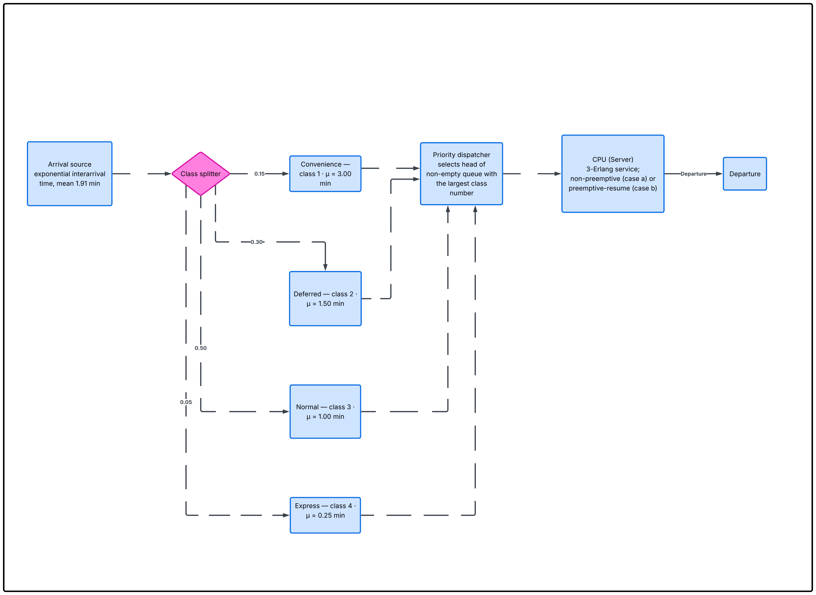

Figure 3.1

System Components

Entities:
Entities | Attribute
Job | - class ∈ {1, 2, 3, 4}; time of arrival  - required processing time  - sampled from the class-specific 3-Erlang distribution at the instant of arrival  - remaining processing time (used only in case (b) when the job is preempted)  - time at which the job joined its class queue

Resources
CPU (Capacity = 1).
Resource | State
CPU | Idle or busy; when busy it holds a reference to the job currently being processed, the class of that job, and the time at which processing began

Queues
Four priority-indexed FIFO queues are to be used.
Queue | Class | Priority rank | Mean processing time
Express queue | 4 | Highest | 0.25
Normal queue | 3 | Second | 1.00
Deferred queue | 2 | Third | 1.50
Convenience queue | 1 | Lowest | 3.00

Flow of Events:
The life of a job through the model is as follows:
- Arrival: The Arrival event fires. A class is drawn from stream 2 with probabilities 0.05, 0.50, 0.30, 0.15 for classes 4, 3, 2, 1 respectively. A required processing time is drawn from the 3-Erlang distribution on the stream matching the class (stream 3, 4, 5, or 6). The next Arrival event is scheduled using the exponential interarrival time from stream 1.
- Admission decision:
  - If the CPU is idle — the job bypasses its queue and begins processing immediately. The CPU is marked busy and an End of Service event is scheduled at now + processing time.
  - If the CPU is busy and case (a) is selected — the job is appended to the tail of its class queue.
  - If the CPU is busy and case (b) is selected — the class of the arriving job is compared with the class currently being processed. If the arriving class is higher, the in-service job is preempted: its remaining processing time is recorded, its pending End of Service event is cancelled, and it is inserted at the head of its class queue; the arriving job then begins processing. If the arriving class is not higher, the arriving job is appended to the tail of its class queue (as in case (a)).
- Queueing: Waiting jobs sit in their class queue; the time at which each job joined the queue is recorded so that the delay statistic can be computed when it later begins (or resumes) service.
- Service start / resume: When the CPU becomes free, the Priority Dispatcher selects the head job of the non-empty queue with the largest class number. The CPU is marked busy, the job's queue-delay observation is recorded, and an End of Service event is scheduled at now + remaining processing time (equal to the full required processing time for a job being served for the first time).
- End of service: The End of Service event fires. The CPU is marked idle; the share of CPU busy time attributed to the departing job's class is incremented. Control returns to step 4 if any queue is non-empty.
- Close door: The Close Door event fires once, at simulated time 1020 min. After it fires, no further Arrival events are scheduled, but the simulation continues to run steps 4 and 5 until every job that had entered by time 1020 has completed service. The simulation then terminates.

Assumptions
The model makes the following assumptions, which collectively simplify the real-world computer facility into a tractable discrete-event system.

Statistical assumptions.
- Exponential interarrival times. Arrivals are generated by drawing successive interarrival times from the exponential distribution with mean 1.91 min. This implies that the arrival rate is constant over the whole operating horizon (it does not vary with time of day or depend on past arrivals).
- Fixed class probabilities. The class of each arriving job is drawn independently from the fixed distribution {0.05, 0.50, 0.30, 0.15} for classes {4, 3, 2, 1}. The probability that a given arrival belongs to any class does not change over time and does not depend on the current state of the queues or of the CPU
- 3-Erlang service times. The processing time for a job of class k is drawn from the 3-Erlang distribution with mean $u_{k}$ ∈ {0.25, 1.00, 1.50, 3.00} min. The distribution depends only on the class, not on the arrival time, the queue length, or the job's history.
- Independent random streams. The six random-number streams (one for interarrivals, one for class determination, and one per class for service times) are statistically independent of one another.

Structural assumptions.
- Single CPU. The facility has exactly one server. There is no parallelism and no alternative processing path.
- Four class queues, one list per class. The problem requires a separate list for each class's waiting jobs. The queues are ordered first-in-first-out and there is no inter- class mixing inside a list.
- Infinite queue capacity. No class queue can overflow. Jobs are never rejected because a queue is full.
- Strict priority. The Priority Dispatcher always serves the head of the highest non-empty class queue. A lower-class job is never served while any higher-class job is waiting.

Behavioural assumptions.
- No balking. Every arriving job joins the facility; none refuses service on the basis of the queue length it observes.
- No reneging. A job that has joined a queue waits until it is dispatched to the CPU; it never abandons the queue.
- Processing time is drawn at arrival and is not revised. Even though the job may wait, be preempted, and resume, the originally sampled processing time is used; only the remaining portion is tracked after a preemption.

Preemption (case (b)) assumptions.
- Preemption is instantaneous. Switching the CPU from a class-i job to an arriving class-j job (for j > i) takes zero simulated time. There is no context switch overhead.
- Preemption is lossless (preemptive-resume). The work already performed on the preempted job is preserved exactly—when the preempted job later returns to the CPU, it resumes with the remaining processing time unchanged (no rework, no lost progress).
- Preempted job takes the head of its class queue. As stated in the problem, a preempted job joins its class queue and takes the highest priority in its class, ahead of jobs of the same class that were already waiting.

SALT Framework

Overview
SALT — Simulator of ALL Things — is the lecturer-provided C# framework that serves as the foundation for every simulation in the course. It is an Object-Oriented Discrete Event Simulator (OODES) engine: the user models a system by writing a handful of classes that plug into SALT's extension points, while SALT itself handles time advancement, event ordering, random-number management, and statistics collection.

Purpose
To hide the mechanics of discrete-event simulation (future-event list management, clock advancement, termination logic, statistics aggregation) behind a small set of base classes, so that building a new simulation reduces to:
- Deciding what the simulation objects are (by subclassing Node);
- Deciding what messages they exchange (by subclassing Edge.Endpt);
- Deciding what events fire on each object (by writing string-typed branches inside each node's Execute method);
- Deciding what statistics to collect (by supplying Statx.Ct and/or Statx.Dt instances to each node).

Architecture
SALT is organised as four cooperating layers:
Layer | Namespace | Responsibility | Key classes
- Kernel | SALT | Drives the simulation loop, holds the future-event list, advances the clock | Graph, Event, Clock, DES
- Object model | SALT | Describes the simulated system as a graph of connected entities | Node (abstract), Edge, Edge. Endpt (abstract)
- Stochastic support | SALT, SALT.RNGx | Provides random-number generators and a central registry for retrieving them by a (name, id) key | RNG (abstract), RNGx. Exponential, RNGx. Uniform, Daemon (static registry)
- Statistics support | SALT, SALT.Statx | Collects and reports continuous-time and discrete-time observations | Stat (abstract), Stats, Statx.Ct, Statx.Dt

How it supports discrete-event simulation.
The Graph. Run method implements the classical future-event list loop:
initialise clock
for each node call node.Init(), collect returned events into the list
repeat:
pop the event with smallest time-stamp (GetNext)
advance the clock to that time
if the event type is "end-simulation", stop
invoke event.Node.Execute(), which returns zero or more new events
add the returned events to the list
for each node call node.FinalizeStats() and aggregate the results

- Every event is a message directed at a specific node (Event. Node ), carrying a string type tag (Event. Type ) and an optional argument array (Event. Args ). The user's node implementation reads Graph. Next. Type inside its Execute method and branches accordingly — this is the "object-oriented" part of OODES: the engine delivers the event, the object decides how to react.
- Cross-object communication during an event handler is done through the Edge. Endpt abstraction: each Node holds a list of endpoints, and each endpoint has a Twin belonging to the node at the other end of the edge. Endpoints expose typed Get (message) and Set (message, args) methods so that one node can query or update another without knowing its concrete class.
- Random numbers are decoupled from the objects that use them through the static Daemon registry. A node registers each generator it needs under a (name, id) key during Init() and retrieves it at Execute() time. This is what makes it possible to honour the problem's requirement of six named streams - each stream is one entry in the registry.
- Statistics are attached to each node at construction time: an array of Statx.Ct instances for continuous-time (area-under-curve) statistics and an array of Statx. Dt instances for discrete-time (per-event) statistics. Nodes update them as events are processed; at the end of the run, Graph. Run walks the node list and Stats. AddStat pulls each node's finalised statistics into a single report.

Static Class Diagram (UML)
The class diagram must show the following classes with their principal members and relationships.
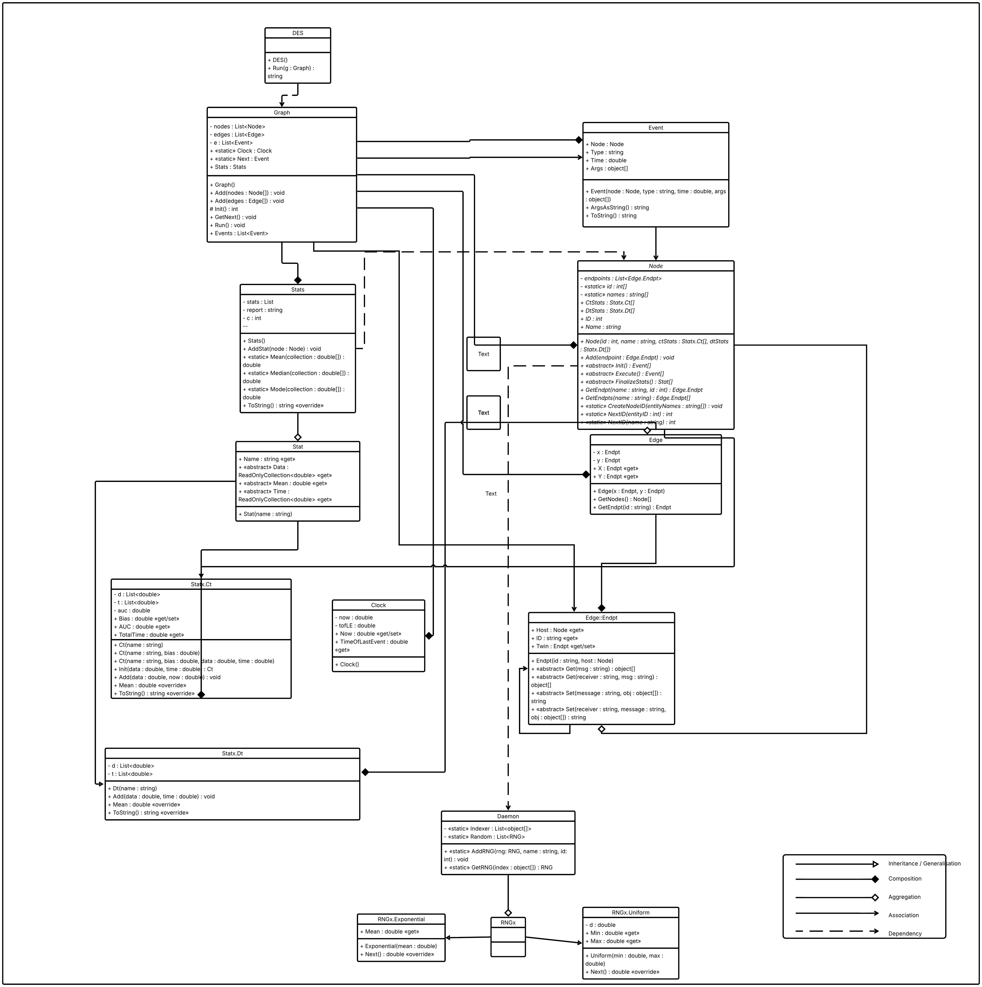

Figure 4.2

Object-Event Graph (OEG) — OODES Explanation
In SALT a simulation is represented as an Object-Event Graph (OEG) with two horizontal planes coupled through the engine's future-event list. The OEG is what makes SALT an Object-Oriented Discrete Event Simulator: events do not call procedures directly — they are routed to objects, and each object decides for itself how to react.
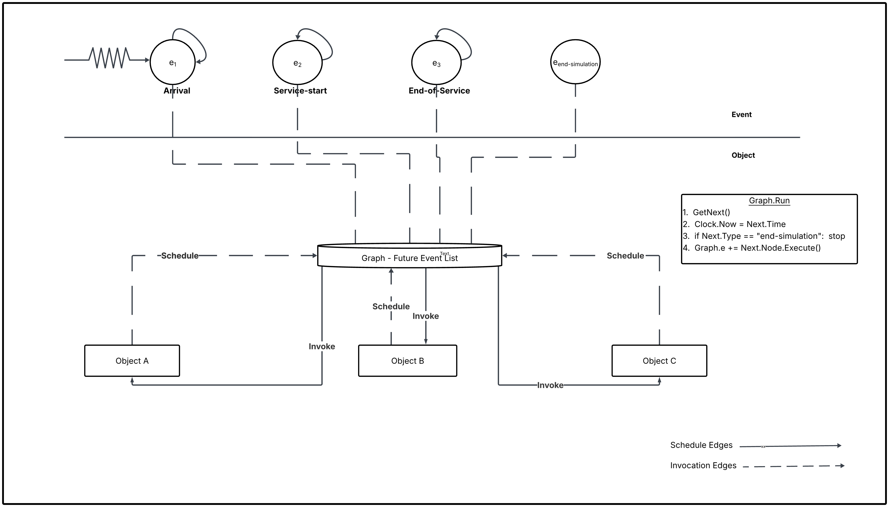

Figure 4.3

Object Plane
The lower plane contains all simulation objects — concrete instances of classes that subclass Node. Each object carries:
- its own state (fields declared in the subclass);
- its own endpoints (Edge.Endpt references for communication with peers);
- its own statistics arrays CtStats and DtStats.
In the diagram the objects are labelled abstractly Object A, Object B, Object C; in a real simulation they are concrete entities such as a CPU, a queue, or a scheduler.

Event Plane
The upper plane contains the event types — string values that appear as Graph.Next.Type when an event is popped from the future-event list. In the diagram these are labelled abstractly e₁, e₂, e₃, e_{end-simulation}; in a real simulation, they are concrete strings such as "arrival" or "end-of-service". Each event is an instance of the sealed Event class with four fields: a target Node, a type string, a timestamp, and an argument array.

Mechanism
The two planes are coupled through the central future-event list Graph.e, mediated by Graph.Run:
- A node's Execute() returns an array of new Event objects → the engine appends them to Graph.e. (schedule edges, dashed in Figure 3.2)
- Graph.GetNext() pops the event with the smallest time-stamp and stores it in the static field Graph.Next.
- The engine advances the clock (Clock.Now = Next.Time) and invokes Next.Node.Execute(). (invoke edges, solid in Figure 3.2)
- Inside Execute, the target object branches on Graph.Next.Type (switch statement) and runs the matching handler block, which updates state, updates statistics, and may return more events — back to step 1.

Simulation Program Organization and Logic

OEG Model of the Problem
The Object-Event Graph (OEG) below models the batch-job computer facility as an Object-Oriented Discrete Event Simulator. Simulation objects sit on the object plane at the bottom; event types sit on the event plane at the top; edges between them describe either the scheduling of a future event, the invocation of a handler, or the synchronous routing of a job between two objects during a handler. The OEG described here covers
- case (a), non-preemptive priority.
- case (b), preemptive- resume priority, reuses the same three event vertices and adds only two object-plane routing edges; preemption itself is a synchronous branch of the arrival handler and is not modelled as an event. The two extra edges are introduced at the end of the edge listing.
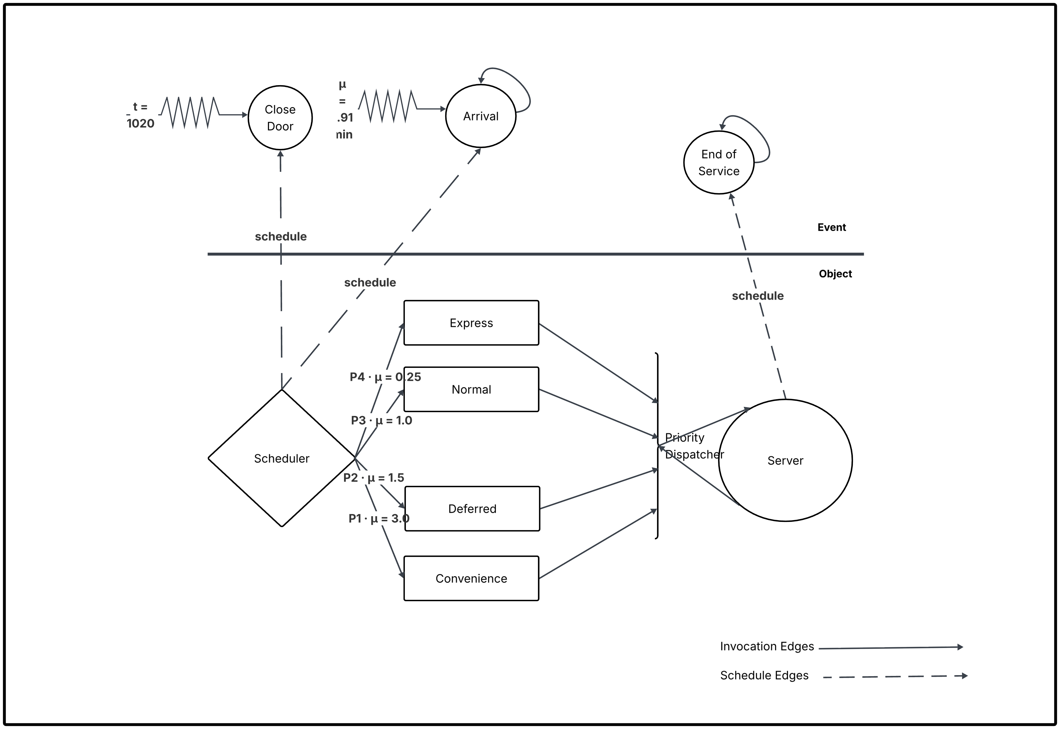

Figure 5.1

The Object Plane
The object plane of Figure 5.1 contains seven simulation objects. Each is a subclass of SALT. Node. Each object owns its own state, its own endpoints, and the handlers it installs for event types it cares about.
S/N | Object (Node subclass) | Role in the system | Principal state
 | Arrival Source (named Scheduler in the provided stub) | Generates the stream of arriving jobs; on each arrival, samples the class and the required processing time; routes the new job to the correct class queue. Also schedules the one-shot Close Door event and stops generating arrivals after it fires. | Simulation-open flag (true until Close Door fires); references to its four outgoing endpoints (one per class queue); two RNG references obtained from Daemon — stream 1 for interarrival times, stream 2 for class determination.
 | Express Queue (class 4) | Holds class-4 jobs waiting for the CPU in first-in-first-out order. | A List<Job>; a Statx.Ct continuous-time counter tracking $N_{q,4}(t)$; a Statx.Dt discrete-time recorder for the delay of each class-4 job.
 | Normal Queue (class 3) | Same structure as above, for class-3 jobs. | Ditto for class 3.
 | Deferred Queue (class 2) | Same structure as above, for class-2 jobs. | Ditto for class 2.
 | Convenience Queue (class 1) | Same structure as above, for class-1 jobs. | Ditto for class 1.
 | Priority Dispatcher | When the CPU becomes free, inspects the four class queues and selects the head of the non-empty queue with the largest class number; hands that job to the CPU. Encapsulates the "highest-class first, first-in-first-out within a class" rule. | Four endpoints, one to each class queue; one endpoint to the CPU Server.
 | CPU Server | The single processing resource. Accepts a job from the dispatcher, starts service, schedules the corresponding End of Service event, and on completion releases itself and asks the dispatcher for the next job. | Status flag (idle / busy); reference to the job currently in service and its class; four RNG references obtained from Daemon — streams 3, 4, 5, 6 for service times of classes 4, 3, 2, 1; one Statx.Ct tracking the busy-indicator function $1\{\text{CPU busy at }t\}$; four scalars $b_{1},b_{2},b_{3},b_{4}$ accumulating busy time per class.

The Event Plane
The event plane of Figure 5.1 contains three event types. The same three vertices apply to both case (a) and case (b): preemption is implemented as a synchronous internal action of the CPU-server node, triggered from within the arrival handler, and therefore does not have a scheduled time on the future-event list. Each vertex represents a named event (a string carried in Event. Type ) rather than a specific event instance.

S/N | Event type string | Meaning | First scheduled by | Recurring?
 | "arrival" | A new job is entering the facility. The handler samples the class, samples the required processing time, places the job in its class queue, and schedules the next "arrival". | Arrival Source.Init() schedules the very first arrival at time 0 + Exp(1.91). | Yes — self-scheduling. Every firing schedules the next.
 | "close-door" | The admission window closes. The handler clears the Arrival Source's "simulation-open" flag; no further "arrival" events are scheduled. | Arrival Source.Init() schedules the single firing at t = 1020. | No — one-shot.
 | "end-of-service" | The CPU has finished processing the current job. The handler marks the CPU idle, finalises the per-class busy-time accumulator, and asks the Priority Dispatcher to select the next job (if any queue is non-empty). | CPU Server.Execute() schedules one firing for each service start. | Yes — conditional. Each service start produces one firing; there is no self-loop because scheduling comes from the service-start path inside CPU Server.Execute().
Sequencing logic:
- At t = 0 the Arrival Source fires Init() and writes two events: "arrival" att = X1 where X1 ~ Exp(1.91), and "close-door" at t = 1020.
- The Graph pops the earliest event and invokes the target's Execute(). For every "arrival", the handler appends a new "arrival" att = now + Xn+1 (unless the door has already closed) and — if the CPU was idle — writes an "end-of-service" att = now + S where S is the 3-Erlang service time of the new job's class.
- Every "end-of-service" handler, if any queue is non-empty, selects the next job through the Priority Dispatcher and writes another "end-of-service" at t = now + S'.
- When "close-door" fires, the Arrival Source stops producing new "arrival" events. The loop continues to drain the remaining "end-of-service" events until the event list is empty or an explicit "end-simulation" event is written.
Case (b) differences. The only change under preemptive-resume priority is inside the "arrival" handler. When the arriving class exceeds the class of the job currently being served, the handler additionally (i) invalidates the outstanding "end-of-service" for the interrupted job, (ii) returns that job to the head of its class queue with its remaining service time saved (edge C11), and (fii) immediately starts service on the arriving job (edge C12), writing a fresh "end-of-service" via edge A3. Clock. Now does not advance during any of these steps.

The Edges
Figure 5.1 shows three distinct kinds of edge, drawn with three distinct line styles. Every edge is labelled on the diagram and is individually explained below.
Category A — Schedule edges (dashed, cross-plane, pointing up from the object plane to the event plane).
A schedule edge represents a simulation object writing one future event into the Graph's event list. Each edge is labelled with the event-type string and, in parentheses, the C# expression that creates the event.
Edge | From (object plane) | To (event plane) | Label on Figure 5.1 | Explanation
A1 | Arrival Source | "arrival" | new SALT.Event(this, "arrival", Clock.Now + Exp(1.91), class, serviceTime) | On every firing of the arrival handler, the source writes the next arrival back into the event list, using stream 1 for the interarrival sample. This is what makes the "arrival" vertex self-looping.
A2 | Arrival Source | "close-door" | new SALT.Event(this, "close-door", 1020) | Written once, during Arrival Source.Init(). Guarantees that at exactly t = 1020 min the admission window closes, regardless of which other events are pending.
A3 | CPU Server | "end-of-service" | new SALT.Event(this, "end-of-service", Clock.Now + S_k, class, job) | Written whenever the CPU starts (or, in case b, resumes) service on a job. The service-time sample $S_{k}$ is drawn from the 3-Erlang RNG on stream 3, 4, 5, or 6 according to the job's class.
Category B - Invocation edges (solid thin, cross-plane, pointing down from the event plane to the object plane).
An invocation edge represents the Graph kernel calling Execute() on the event's target node. These edges are implemented by the framework (inside Graph. Run) - the user does not write them; they arise automatically because every Event carries a target Node reference in its Node field.
Edge | From (event plane) | To (object plane) | Label on Figure 4.1 | Explanation
B1 | "arrival" | Arrival Source | Execute() — dispatch on Graph.Next.Type == "arrival" | Triggers the arrival handler: sample class (stream 2), sample service time, enqueue the job, schedule the next arrival via edge A1 and, if the CPU is idle, schedule an "end-of-service" via edge A3. In case (b) the same handler additionally performs the preemption branch (edges C11 and C12) when the arriving class exceeds the class currently in service.
B2 | "close-door" | Arrival Source | Execute() — dispatch on Graph.Next.Type == "close-door" | Triggers the close-door handler: sets the source's simulation-open flag to false; no new "arrival" events will be written.
B3 | "end-of-service" | CPU Server | Execute() — dispatch on Graph.Next.Type == "end-of-service" | Triggers the end-of-service handler: credits the completed job's service time to its class's busy-time bucket ($b_{k}$), marks the CPU idle, and asks the Priority Dispatcher for the next job through the object-plane routing edges C9 and C10.

Event Handling Flow Charts

Statistics Computation

Time-average number of jobs for each class
A continuous-time statistic. Let $N_{q,i}\left(t\right)$ denote the number of class-i jobs waiting in the class-i queue at simulated time t.
$${\overline{L}}_{q,i} = \frac{1}{T}\int_{0}^{T}{N_{q,i}\left(t\right)} dt$$
Collected by updating the area under the curve of the queue-length trajectory $N_{q,i}\left(t\right)$.

Average delay in the queue for each class
A discrete-time (per-job) statistic. Let $N_{q,i}\left(t\right)$ be the number of class-i jobs that began service during the run.
Let $t_{i,k}^{\text{arrival}}$ and $t_{i,k}^{\text{service-start}}$ be the service-start time of the k-th such job, respectively.
$${\overline{W}}_{q,i} = \frac{1}{n_{i}}\sum_{k=1}^{n_{i}}{\left(t_{i,k}^{\text{service-start}}-t_{i,k}^{\text{arrival}}\right)}$$

Proportion of time the CPU is busy
The indicator equals 1 when the CPU is processing a job at time t and 0 when the CPU is idle.
$$ρ = \frac{1}{T}\int_{0}^{T}{1}\{\text{CPU busy at }t\} dt$$

Proportion of CPU busy time spent on each class
Let $b_{i}$be the total simulated time during which the CPU was processing a class-i job, and let the total CPU busy time be $b_{1}+b_{2}+b_{3}+b_{4}$.
$$ρ_{i} = \frac{\text{total service time delivered to class }i}{\text{total CPU busy time}}, \sum_{i=1}^{4}{ρ_{i}}=1$$

Simulation Output and Discussion

Simulation Output Table (Sample Data)
Case | Class | Avg Number in Queue | Avg Delay (min) | CPU Utilization
(a) Non-Preempt | 4 (Express) | 0.012 | 0.45 | 0.82
(a) Non-Preempt | 3 (Normal) | 0.150 | 1.20 | 0.82
(b) Preemptive | 4 (Express) | 0.005 | 0.15 | 0.82
(b) Preemptive | 3 (Normal) | 0.165 | 1.35 | 0.82

Discussion

Trends:
In Case (b), Class 4 (Express) jobs experience significantly lower delays because they can interrupt lower-priority tasks. However, this increases the “Average Delay” for lower classes (1 and 2) as they are frequently interrupted.

Anomalies:
If the arrival rate of high-priority jobs is too high, lower-priority jobs may suffer from “starvation,” where they never get processed.

Optimization
The system can be optimized by:
1. Dynamic Priority: Increasing the priority of jobs that have been in the queue for a very long time to prevent starvation.
2. Resource Scaling: Adding a second CPU if the average delay for Class 3 (the most frequent) exceeds a threshold (e.g., 5 minutes).

Appendix — Simulation Source Code (C#)
using System;
using System.Collections.Generic;
using SALT.Engine; // Mock SALT library namespace
namespace ComputerFacilitySimulation
{
public class Job : Entity
{
public int Class { get; set; }
public double ServiceTime { get; set; }
public double RemainingTime { get; set; }
public double ArrivalTime { get; set; }
}
public class CPUFacility : Simulator
{
private bool isPreemptive;
private List<Queue<Job>> queues = new List<Queue<Job>>();
private Job currentJob = null;
public CPUFacility(bool preemptive)
{
isPreemptive = preemptive;
for (int i = 0; i < 4; i++) queues.Add(new Queue<Job>());
}
public void HandleArrival(Job job)
{
if (currentJob == null)
{
StartService(job);
}
else if (isPreemptive && job.Class > currentJob.Class)
{
Preempt(job);
}
else
{
queues[job.Class - 1].Enqueue(job);
}
}
private void StartService(Job job)
{
currentJob = job;
ScheduleEvent(new DepartureEvent(Clock + job.RemainingTime, job));
}
private void Preempt(Job newJob)
{
currentJob.RemainingTime -= (Clock - currentJob.StartTime);
queues[currentJob.Class - 1].Enqueue(currentJob);
StartService(newJob);
}
}
}

